City of Woodbranch Village

Mike Tyson, Mayor | Trisha Marie Cranncy, Council Position 3
Scottie Garner, Council Position 1 | Nancy Mulhcrn, Council Position 4
Stacey Shipley, Council Position 2 | James Mulkcy, Council Position 5

NOTICE OF REGULAR MEETING
[The City Council for the City of Woodbranch reserves the right to adjourn into Executive Session at any time during the course of this meeting to discuss any of the matters listed as authorized by Texas Government Code, Section 551.071 (Consultation with Attorney); 551.072 (Deliberation about Real Property); 551.073 (Deliberations about Gifts & Donations); 551.074 (Personnel Matters); 551.076 (Deliberation about Security Devices); and 551.087 (Deliberations Regarding Economic Development Negotiation)].
NOTICE IS HEREBY GIVEN that the Regular Meeting of the City Council of the City of Woodbranch Village, Texas, will be held in the City of Woodbranch Village City Hall at 58A Woodbranch Drive, New Caney, Texas on Thursday, the 24th day of September 2026 at 6:00 P.M. for the purpose of considering the items of business described in the accompanying Agenda to-Wit:
REGULAR MEETING (6:00 P.M.)
l. Call to Order
- Roll call
- Prayer
- Pledge of allegiance to the American Flag
- Citizens' Comments, Requests or Petitions from the Public (This agenda item provides an opportunity for citizens to address the City Council on any matter not on the agenda).
Comments shall be limited to three (3) minutes per person. Comments by the governing body shall be limited to:
  - Statements of specific factual information given in response to an inquiry;
  - A recitation of existing policy in response to an inquiry;
  - A proposal to place the subject on a future agenda.

CONSENT AGENDA
No discussion is anticipated on any of the items in this section because they are routine business, were included in the budget adoption process, or have been previously discussed as a staff report or discussion item. These items will be considered collectively by a single vote, unless a council member requests an item be removed from the consent agenda.
- Approve Minutes from August 27, 2026 - Regular Meeting
- Approve Financial Statement for General Fund — August 2026
- Approve Financial Statement for Water Sewer Fund — August 2026
- Approve Financial Statement for Debt Service Fund - August 2026
- Approve Bills General Fund - September 2026
- Approve Bills Water Sewer Fund — September 2026
- Approve Bills Debt Service Fund — September 2026
- Approve the Court Activity Report — August 2026
- Approve Road Ditch Report and Storm Water Management Report — August 2026
- Approve the Building Permit Activity Report — August 2026
- Approve the Nuisance and Abatement Activity Report — August 2026
- Approve the City Administrator's Activity Report — August 2026
- Approve the City Engineer Activity Report — August 2026

STAFF REPORTS AND MONTHLY REPORTS FROM THE FOLLOWING
Items in this section are not expected to require action by City Council and are generally for information only. However, all items listed in this section may become action items on request of any Council Member, and City Council may take action on any item listed in this section without further notice.
Police Activity Report — August 2026

Operator's Report — August 2026

19. Consider Resolution 0917-2026 a resolution to cast the ballot for candidate appointment to the GRP Contract Review Committee (Mike Tyson, Mayor)
20. Consider the letter of resignation submitted by Municipal Court Clerk, Cassandra Stewart (Mike Tyson, Mayor)
21. Consider the appointment of a new Municipal Court Clerk (Mike Tyson, Mayor)
22. Closed Executive Session in Accordance with the Open Meetings Act TEX. GOV’T CODE 551.074 – to deliberate Closed Executive Session in Accordance with the Open Meetings Act TEX. GOV’T CODE 551.074 – to deliberate the appointment, employment, evaluation, reassignment, duties, discipline and or dismissal of a public officer or employee; potential candidate for Full-Time Police Officer; Melissa Griffen.
23. Reconvene and take possible action
24. Mayor's comments on infrastructure, city budget and grant opportunities
25. Item of Community Interest - (Hear announcements concerning items of community interest from the Mayor,
Councilmembers, and City staff for which no action will be discussed or taken.)
26. Adjourn

Persons with disabilities who plan to attend this meeting and who may need auxiliary aids or services are requested to contact Shari McMinn, at 281-399-3979, two working days prior to the meeting so appropriate arrangements can be made.

CERTIFICATE
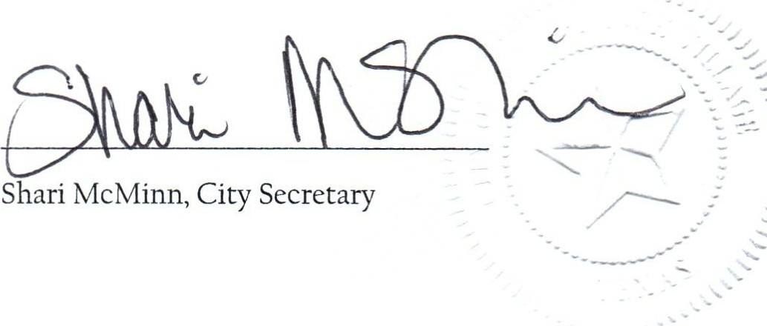
I, Shari McMinn, City Secretary, do hereby certify that a copy of the regular meeting of September 24th, 2026, City of Woodbranch Village City Council Agenda, was posted on the City Hall bulletin board, a place of convenient and readily accessible to the general public at all times, in compliance with Chapter 551, Texas Government Code.
DATE OF POSTING: Thursday, September 17th, 2026
TIME OF POSTING: 4:00 P.M.



